Payload

📦 What Is a Payload in Network Data Structures?
# Source: AI Source: Provided by: [Data Path: Persons Table -> ID Column: 1, Name_En Column: Motasem Essam] -> From: [ChatGPT] on [1/16/2026]
A payload is the actual data being transmitted over the network — the core content the sender wants to deliver, excluding headers and trailers. It can be a file, a video stream, an email, or part of a webpage — depending on the application.

🧠 Simple Definition:
# Source: AI Source: Provided by: [Data Path: Persons Table -> ID Column: 1, Name_En Column: Motasem Essam] -> From: [ChatGPT] on [1/16/2026]
A payload is the main body of data carried inside a network packet, frame, or segment — it's the "useful" information, not the technical metadata.

🔍 Where Payload Appears (in OSI Model):
# Source: AI Source: Provided by: [Data Path: Persons Table -> ID Column: 1, Name_En Column: Motasem Essam] -> From: [ChatGPT] on [1/16/2026]
Each layer wraps the payload from the layer above it. The payload at one layer becomes the full data unit at the next lower layer:
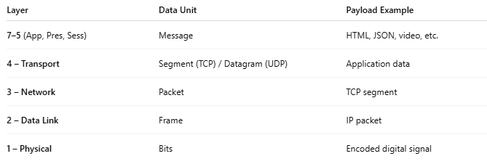
Layer | Data Unit | Payload Example
7–5 (App, Pres, Sess) | Message | HTML, JSON, video, etc.
4 – Transport | Segment (TCP) / Datagram (UDP) | Application data
3 – Network | Packet | TCP segment
2 – Data Link | Frame | IP packet
1 – Physical | Bits | Encoded digital signal

🎯 Example: IP Packet
# Source: AI Source: Provided by: [Data Path: Persons Table -> ID Column: 1, Name_En Column: Motasem Essam] -> From: [ChatGPT] on [1/16/2026]
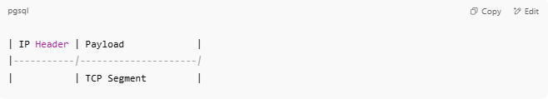
| IP Header | Payload |
|-----------|---------------------|
| | TCP Segment |

And inside the TCP segment:
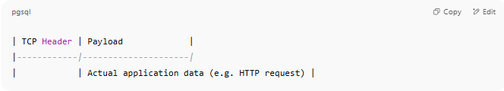
| TCP Header | Payload |
|------------|---------------------|
| | Actual application data (e.g. HTTP request) |

🧱 Payload – Visual Example
# Source: AI Source: Provided by: [Data Path: Persons Table -> ID Column: 1, Name_En Column: Motasem Essam] -> From: [ChatGPT] on [1/16/2026]
Absolutely! Here's a 🧱 Visual Example of a Payload — showing how it fits inside network data structures like TCP/IP packets. We'll peel back the layers to expose the actual user data (payload) at each step.

🧱 Visual Breakdown: Payload Across Layers
# Source: AI Source: Provided by: [Data Path: Persons Table -> ID Column: 1, Name_En Column: Motasem Essam] -> From: [ChatGPT] on [1/16/2026]
Imagine you're opening a website:
GET /index.html HTTP/1.1

▶ Application Layer Payload (Layer 7)
# Source: AI Source: Provided by: [Data Path: Persons Table -> ID Column: 1, Name_En Column: Motasem Essam] -> From: [ChatGPT] on [1/16/2026]
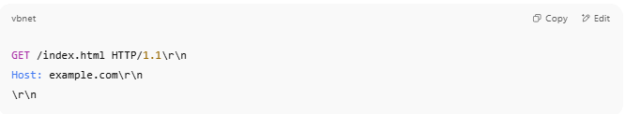
GET /index.html HTTP/1.1\r\n
Host: example.com\r\n
\r\n

🔹 This is the true payload — user data.

▶ Transport Layer Segment (TCP – Layer 4)
# Source: AI Source: Provided by: [Data Path: Persons Table -> ID Column: 1, Name_En Column: Motasem Essam] -> From: [ChatGPT] on [1/16/2026]
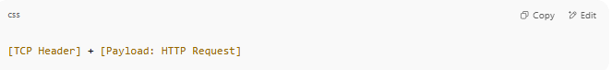
[TCP Header] + [Payload: HTTP Request]

🧱 Payload here:
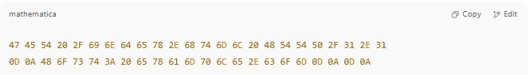
47 45 54 20 2F 69 6E 64 65 78 2E 68 74 6D 6C 20 48 54 54 50 2F 31 2E 31
0D 0A 48 6F 73 74 3A 20 65 78 61 6D 70 6C 65 2E 63 6F 6D 0D 0A 0D 0A

🔍 This is the HTTP GET request in hexadecimal (the payload of the TCP segment).

▶ Network Layer Packet (IP – Layer 3)
# Source: AI Source: Provided by: [Data Path: Persons Table -> ID Column: 1, Name_En Column: Motasem Essam] -> From: [ChatGPT] on [1/16/2026]
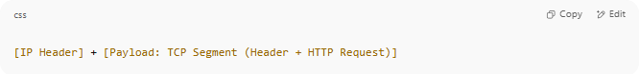
[IP Header] + [Payload: TCP Segment (Header + HTTP Request)]

🧱 Payload here:
- The entire TCP segment, including its own header and the HTTP request.

▶ Data Link Layer Frame (Ethernet – Layer 2)
# Source: AI Source: Provided by: [Data Path: Persons Table -> ID Column: 1, Name_En Column: Motasem Essam] -> From: [ChatGPT] on [1/16/2026]
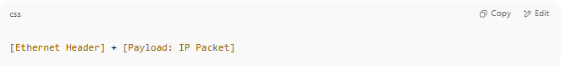
[Ethernet Header] + [Payload: IP Packet]

🧱 Payload here:
- The entire IP packet, including its header and everything it carries.

🧾 Simplified View
# Source: AI Source: Provided by: [Data Path: Persons Table -> ID Column: 1, Name_En Column: Motasem Essam] -> From: [ChatGPT] on [1/16/2026]
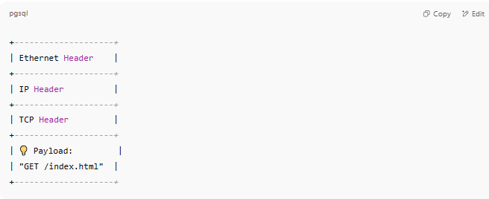
+--------------------+
| Ethernet Header |
+--------------------+
| IP Header |
+--------------------+
| TCP Header |
+--------------------+
| 💡 Payload: |
| "GET /index.html" |
+--------------------+

✅ Summary Table
# Source: AI Source: Provided by: [Data Path: Persons Table -> ID Column: 1, Name_En Column: Motasem Essam] -> From: [ChatGPT] on [1/16/2026]
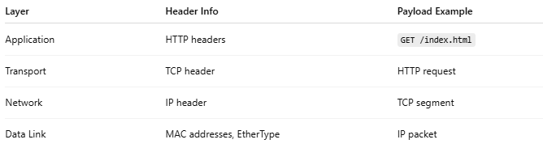

Layer | Header Info | Payload Example
Application | HTTP headers | GET /index.html
Transport | TCP header | HTTP request
Network | IP header | TCP segment
Data Link | MAC addresses, EtherType | IP packet

📌 Payload Is:
# Source: AI Source: Provided by: [Data Path: Persons Table -> ID Column: 1, Name_En Column: Motasem Essam] -> From: [ChatGPT] on [1/16/2026]
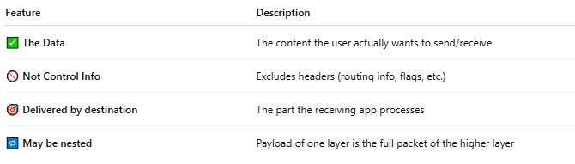
Feature | Description
✅ The Data | The content the user actually wants to send/receive
🚫 Not Control Info | Excludes headers (routing info, flags, etc.)
🎯 Delivered by destination | The part the receiving app processes
🔁 May be nested | Payload of one layer is the full packet of the higher layer

📦 Payload in Action (Example: Sending a Web Page)
# Source: AI Source: Provided by: [Data Path: Persons Table -> ID Column: 1, Name_En Column: Motasem Essam] -> From: [ChatGPT] on [1/16/2026]
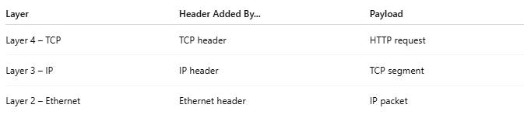
Layer | Header Added By... | Payload
Layer 4 – TCP | TCP header | HTTP request
Layer 3 – IP | IP header | TCP segment
Layer 2 – Ethernet | Ethernet header | IP packet

✅ Summary
# Source: AI Source: Provided by: [Data Path: Persons Table -> ID Column: 1, Name_En Column: Motasem Essam] -> From: [ChatGPT] on [1/16/2026]
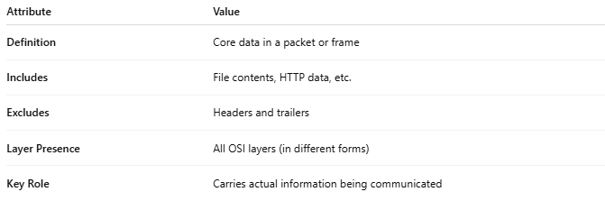
Attribute | Value
Definition | Core data in a packet or frame
Includes | File contents, HTTP data, etc.
Excludes | Headers and trailers
Layer Presence | All OSI layers (in different forms)
Key Role | Carries actual information being communicated

